SWEDEN/CLARKSON RECREATION
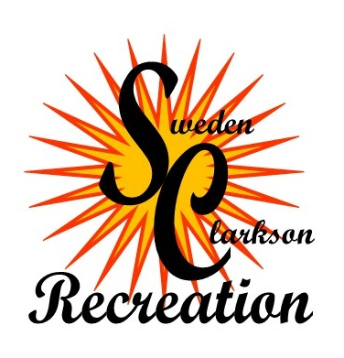
4927 LAKE ROAD
BROCKPORT, NY 14420
PHONE: (585) 431-0090
FAX: (585) 431-0052

SWEDEN/CLARKSON RECREATION
GRANT GUIDELINES & PROCEDURES

In keeping with its mission of providing support for safe, innovative and cost effective recreation and park programs; the recreation department has implemented a procedure by which a limited number of youth may receive grant assistance to help defray a portion of the cost of program registration fees. These grants may be awarded to families or individuals that demonstrate a legitimate need for recreation department support.
Please note that it is not intention of the S/C Recreation Department to provide in excess of 75% of an individual’s registration fee for any individual and/or for any program.

CRITERIA FOR SWEDEN/CLARKSON
RECREATION GRANT

The intended youth recipient is required to meet the following three conditions in order to be considered for an S/C Recreation Department Grant:
- The intended youth recipient must reside in either the Town of Sweden or the Town of Clarkson.
- The applicant (adult) must be willing and able to demonstrate a legitimate need for grant assistance.
- Any grant awarded must be used specifically to enhance the quality of life of the intended youth recipient through the recipient’s consistent participation in the program for which the grant was awarded.

PROCEDURES FOR SUBMITTING
SWEDEN/CLARKSON RECREATION
GRANT APPLICATIONS

- Fully completed grant application forms must be submitted to the Recreation Director at lease one month in advance of the start date of the program for which grant assistance is being sought.
- The Recreation Director will read over all eligible applications (applications meeting the above criteria) and determine approval/disapproval. Please make sure that you allow enough time for the Recreation Director to consider your application.
- If a grant application is approved by the Recreation Director, the Recreation Department will contact the applicant in writing regarding the amount of assistance that has been approved.

SWEDEN/CLARKSON RECREATION
APPLICATION FOR YOUTH PROGRAM GRANT

PARENT NAME:

ADDRESS:

HOME PHONE: WORK PHONE:

INDIVIDUAL(S) FOR WHICH GRANT ASSISTANCE IS BEING SOUGHT (MAX 2):

NAME: AGE:

NAME: AGE:

AMOUNT OF ASSISTANCE REQUESTED:
(MAXIMUM: 50% OF PROGRAM REGISTRATION FEE FOR EACH INDIVIDUAL)

DATE PROGRAM IS SCHEDULED TO BEGIN:

PLEASE GIVE A BRIEF DESCRIPTION OF HOW THE FUNDING WOULD BENEFIT THE INTENDED YOUTH RECIPIENT:

PLEASE PLACE AN X IN ANY OR ALL OF THE FOLLOWING THAT APPLY TO YOUR SITUATION:
UNEMPLOYED AND RECEIVING TEMPORARY ASSISTANCE THROUGH D.S.S.
UNEMPLOYED, DISABLED AND RECEIVING SSI OR SSD
UNEMPLOYED AND RECEIVING UNEMPLOYMENT
EMPLOYED FULL-TIME
EMPLOYED PART-TIME
FAMILY HARDSHIP (DEATH OF A SPOUSE, DIVORCE, SINGLE PARENT)

OTHER (PLEASE EXPLAIN: )

FAMILY DESCRIPTION:

NUMBER OF FAMILY MEMBERS (INCLUDING SELF) RESIDING IN YOUR HOUSE:

DATE OF BIRTH OF ALL FAMILY MEMBERS IN HOUSE:

PLEASE SUBMIT PROOF OF INCOME (IE. CURRENT PAY STUB, STATEMENT FROM MONROE COUNTY, D.S.S., ETC.)

APPLICANT SIGNATURE:

PROOF OF INCOME IS REQUIRED
UPON SUBMISSION OF APPLICAION

FINANCIAL STATEMENT:

MONTHLY INCOME: MONTHLY EXPENSES:

TOTAL INCOME: $ RENT/MORTGAGE + TAXES: $

FOOD STAMPS: $ MEDICAL EXPENSES: $

CHILD SUPPORT: $

OTHER INCOME: $

TOTAL NET INCOME: $ TOTAL MONTHLY EXPENSES: $

APPLICANT SIGNATURE: DATE:

